**User Manual**

Cleft Lip Aesthetics Tool

This user manual has been created for the purpose of detailing to app users how to make use of all of the features on the app. Installation details are given for both Android and Windows platforms. Outlined below are the steps required for installing and using the app.

**Initial requirements**

The computer being used for running the app must meet the following minimum system requirements:

* Microsoft® Windows® 10 (32- or 64-bit)
* 100 MB of available hard disk space
* 1280 x 768 minimum screen resolution

The mobile being used for running the app must meet the following minimum system requirements:

* Android 4.0 (API level 14) or higher
* 100 MB of available hard disk space
* 1280 x 720 minimum screen resolution

1. **Downloading and installing**

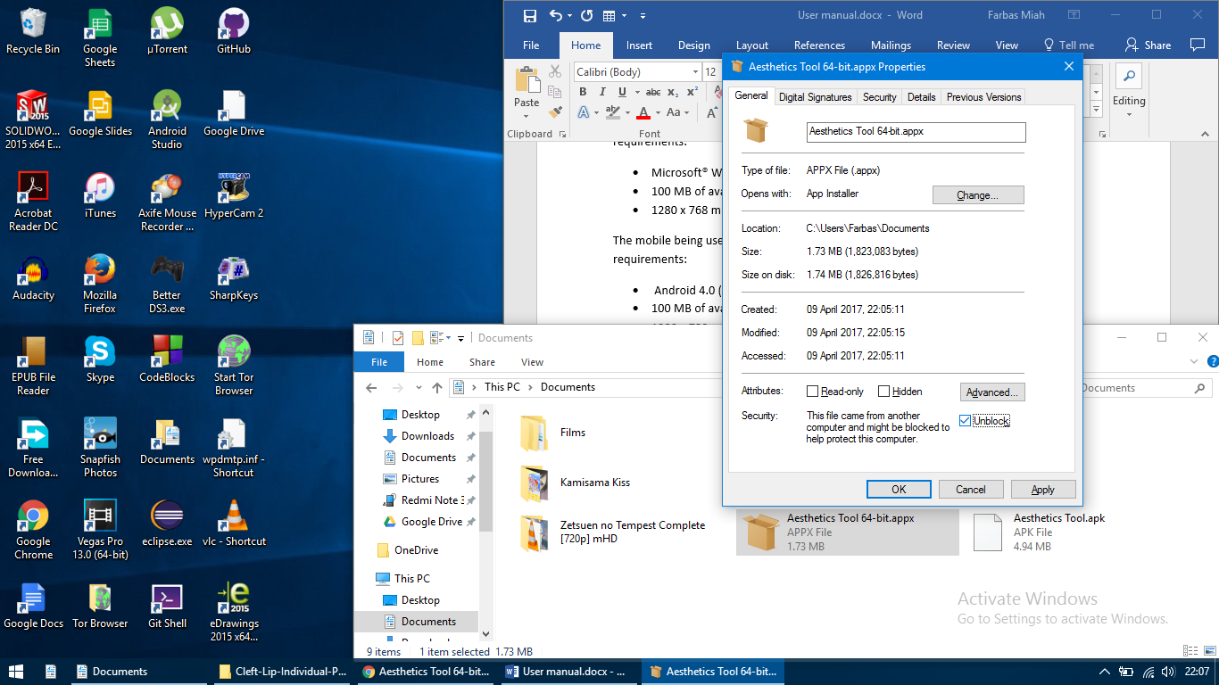To download the app on Windows, download the APPX file from here: <https://drive.google.com/open?id=0B1S0MR8vAfxJUXliS0U0RTJGc0U>

Once downloaded, go to the file location and right click to open the Properties. At the bottom of the tab click on the Unblock box and then press OK as shown in the image to the right.

Double-click on the APPX file to open and click Install. Once installed, click Launch to open the app. The app will now be accessible from the Start menu.

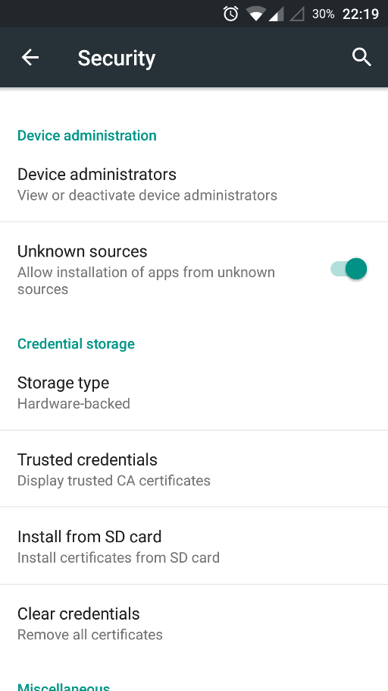To download the app on Android, download the APK file from here: <https://drive.google.com/open?id=0B1S0MR8vAfxJTDVScFhBVWlSdzQ>

Before installing, make sure the device allows installation of apps from unknown sources. This option can be found in the Settings with the location varying between devices. The image to the right demonstrates this option.

Go to the APK download location, open it and then click INSTALL to begin installation. The app will now be accessible from the device’s app list. Click on the app icon to open.

1. **Download patient images & drawings**

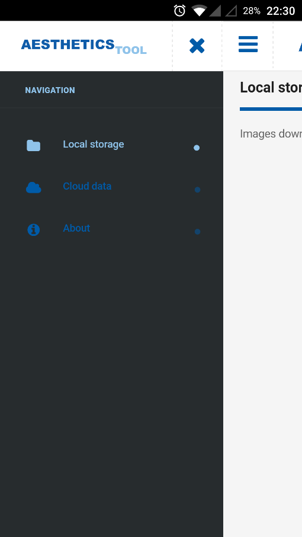To download a patient locally, open the navigation drawer with the toggle button on the top left. Click on Cloud data to load the patient list.

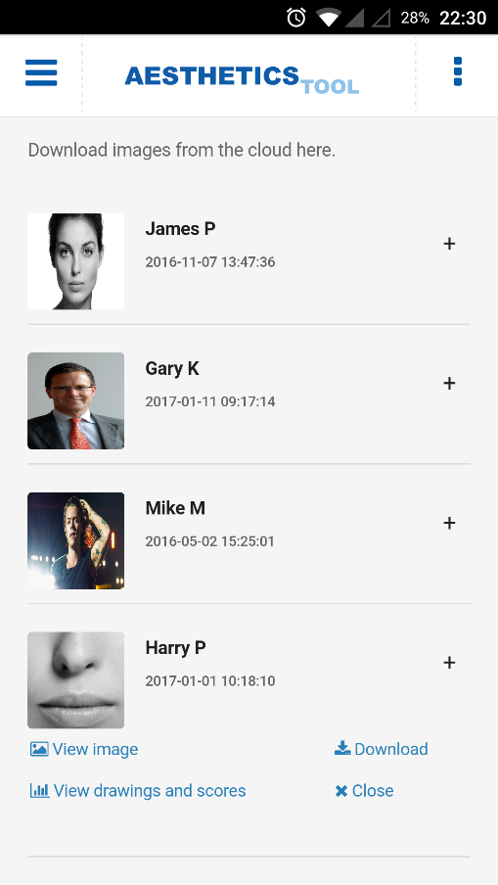All of the available patients will then be listed. Click on the plus symbol for a specific patient to toggle options.

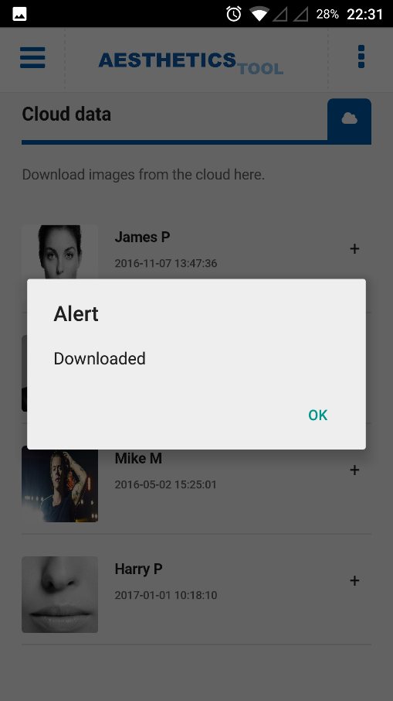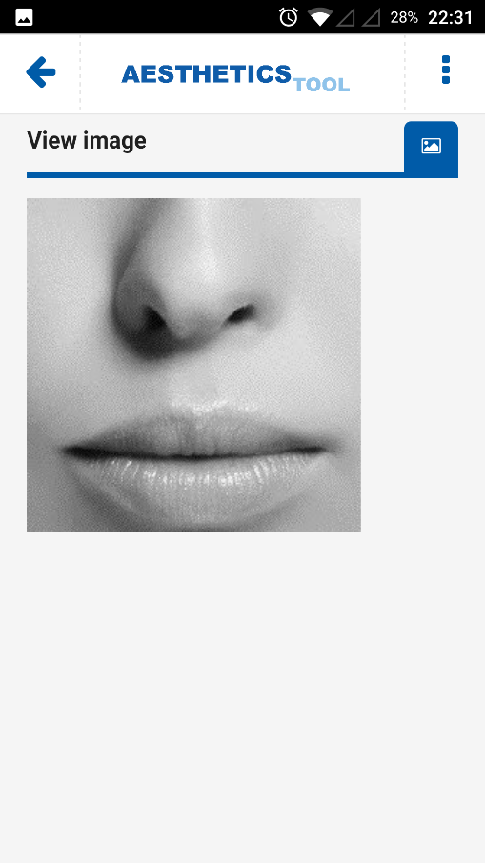To expand the patient’s image, click on View image. Press the back button on the top left to return to the patient list.

To download an image locally, click Download. You will receive a notification once the image has downloaded.

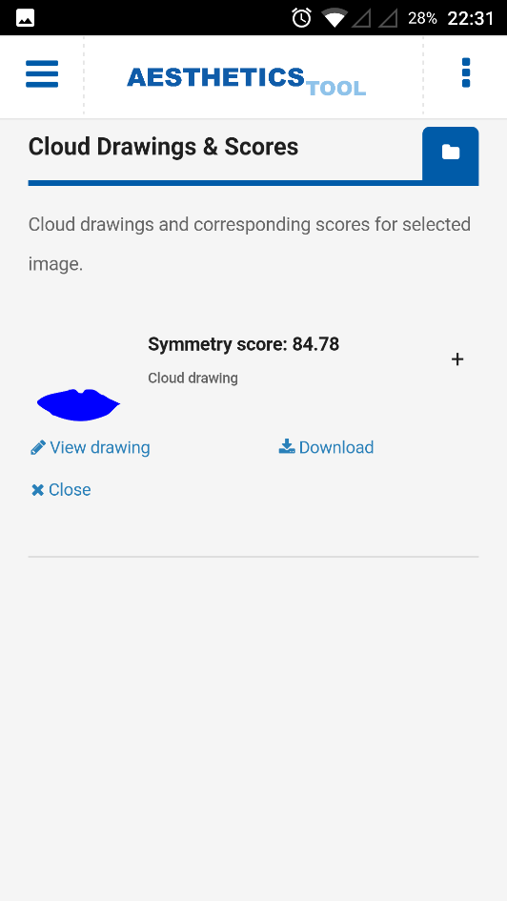To view drawings that have already been uploaded by others previously, click on View drawings and scores. Like the patient images, the drawings will be listed with options that can be toggled for each drawing. Just like the patients, to view the drawing click View drawing and to download the drawing locally click Download.

1. 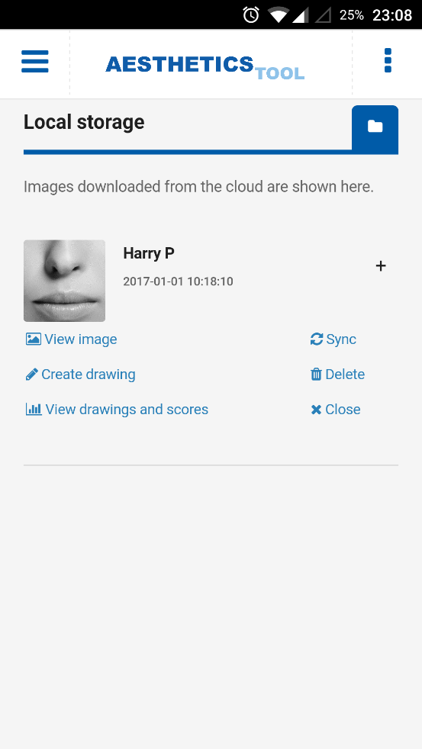**Creating a drawing**

To create a drawing to generate a symmetry score, navigate to the Local storage from the navigation drawer. Patients downloaded locally will be shown here. Use the plus sign to toggle the options for the chosen patient and select Create drawing.

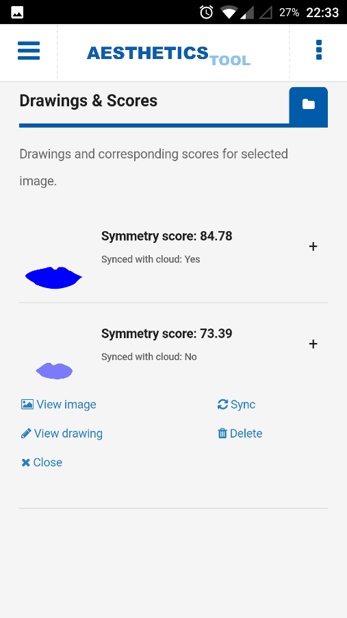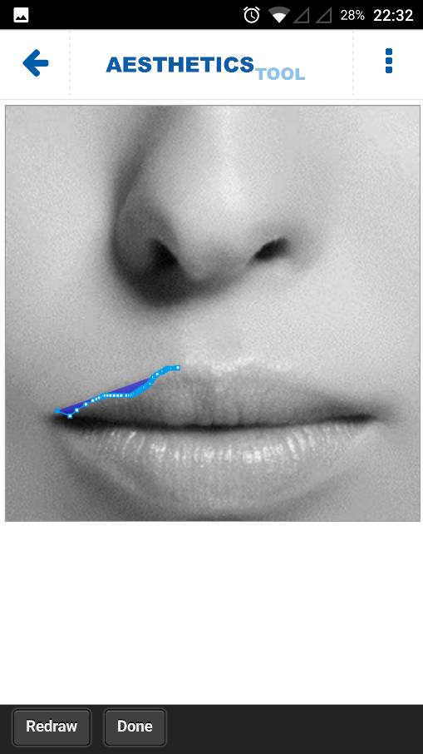Draw over the patient’s image to create a trace of the lip regions and once satisfied, click Done.

All of the local drawings for the specific patient will now be displayed with their corresponding symmetry scores.

1. **Deleting content**

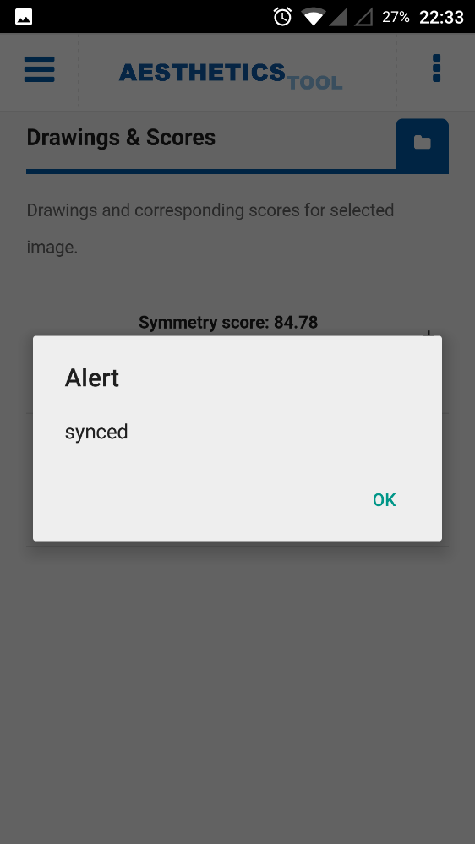In the local storage for the patient list and drawing lists, each patient image and drawing has an option to be deleted. To delete an item, toggle the options with the plus sign and click Delete. If deleting a patient image, all of its corresponding drawings will be deleted too.

1. **Syncing drawings**

Similar to deleting items, the syncing option is available for each patient stored locally and for each drawing stored locally. To sync all drawings for a patient, toggle the options with the plus sign in Local Storage and click Sync. You will receive a notification when the upload has been completed. Alternatively, you can sync individual drawings by selecting Sync in the drawing list for a chosen patient.